Mobile Application Development

Assignment 2.

18309003 Roh sung ho

18309008 Nabil Madih

***Requirements:***

1, The implementation should include but not limited to functions such as,

* Look in the list of courses offered by a e-learing platform
* Navigate to the detailed course introductions such as course info , syllabus, registration and calendar and so on.
* Login to the E-learning platform
* Browse and search the learing materials which can be multi media.

2, User Login input validating is required.

3, Using recyclerview for datasets displaying, e.g, course lists and search results.

4, Datasets such as course information, course materials(course wares) are required to obtain from web server, therefore utilizing apis such as retrofix, picasso and etc may be necessary.

5, For multi-media, such as video/audio lessons, function implementation such as lesson broadcasting is required.

Function 3. Implement the Main page and show the Notice

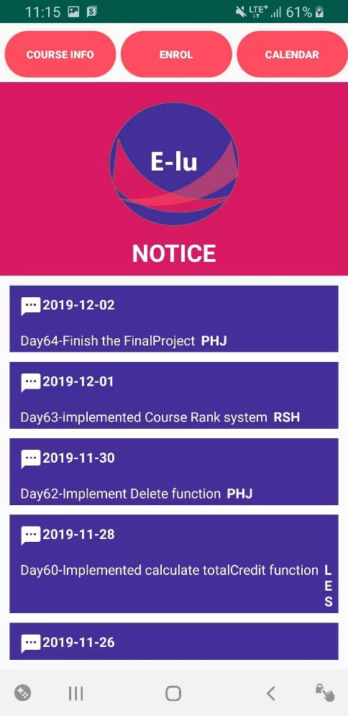

The 3rd function is implemented main page and notice list. This notice list is come from the M_NOTICE table.

Function 4. Search the Course

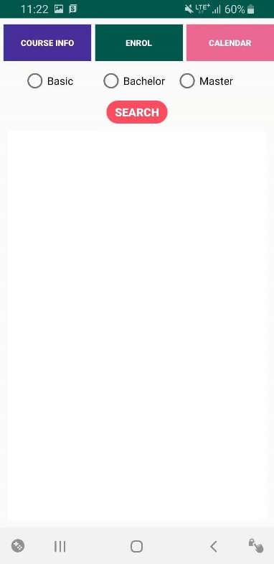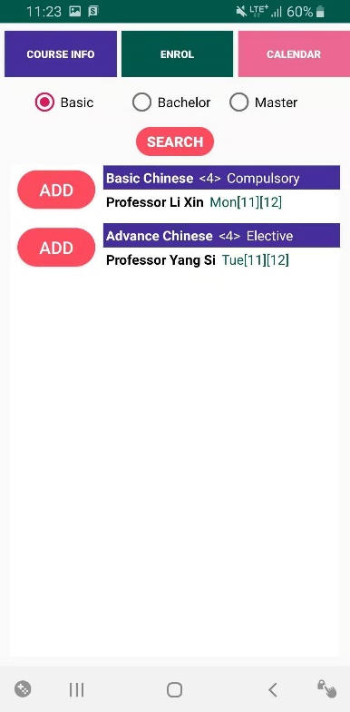

The 4th function is course list. This list is come from the M_COURSE table.

You can search the course list dividing by Bachelor and Master courses. And if you want to take the course, click the ADD button.

The course is stored in the M_SCHEDULE table.